Part A

1.



2.



3.

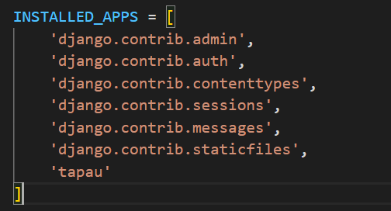

4.

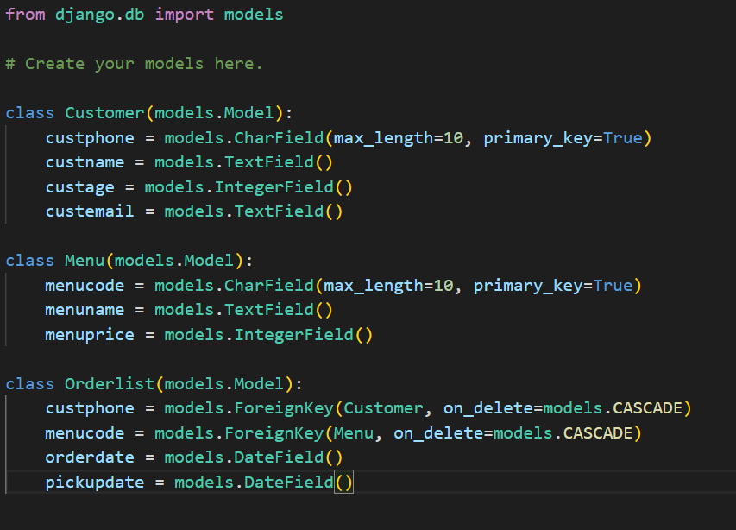

5.

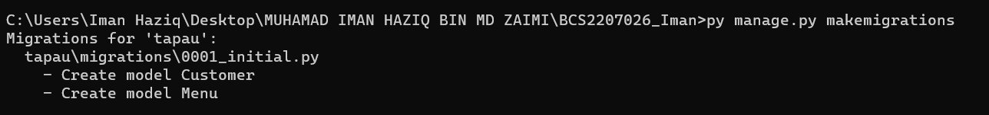

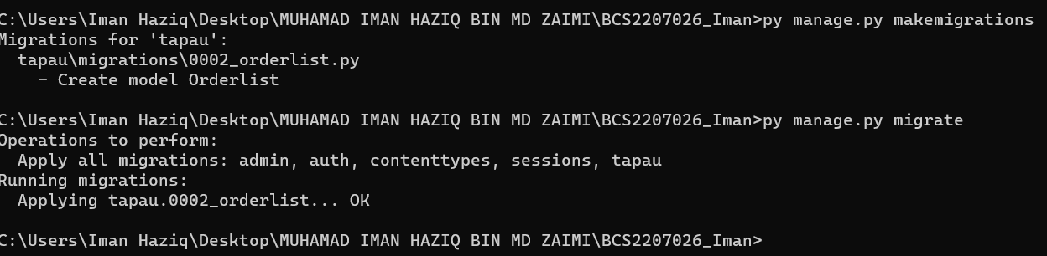

6.

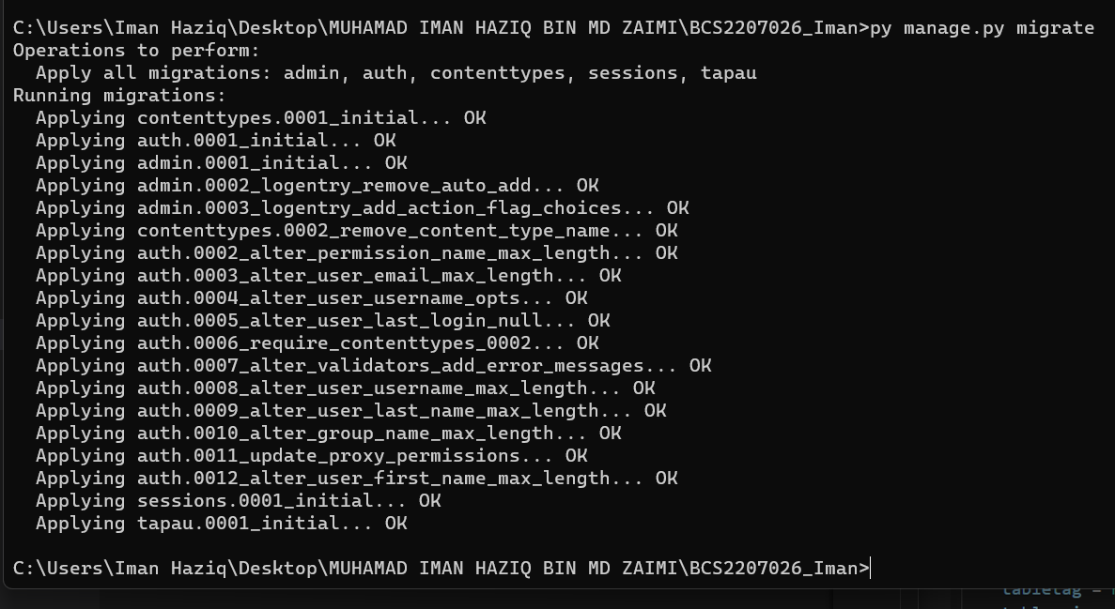



7.

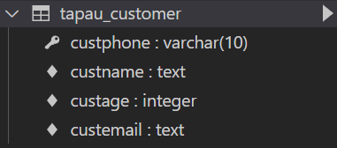

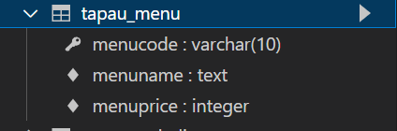

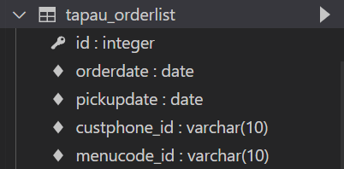

8.

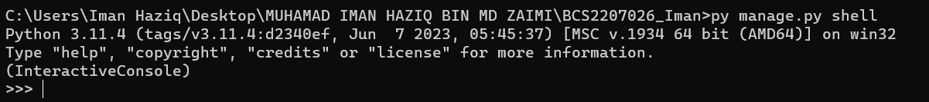

9.



10.

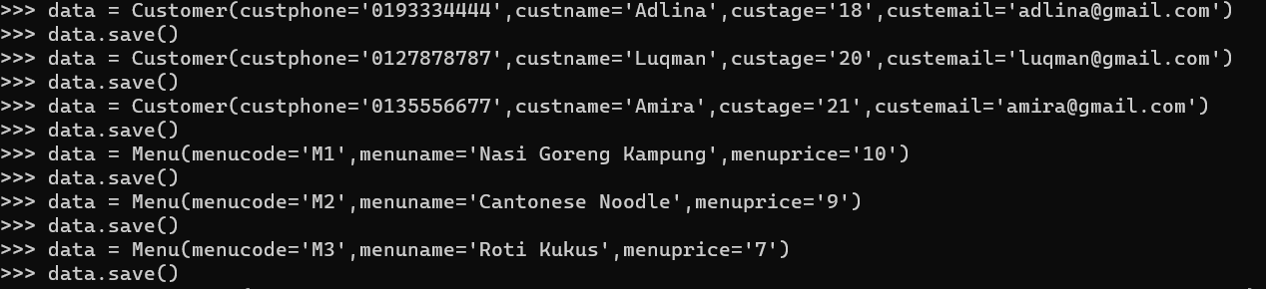

11.

12.

CUSTOMER

MENU

ORDERLIST

13.

14.

15.



16.



17.



18.

